**Assignment # 3**

**BSSE/BSCS – Fall 2015 (Enterprise Application Development)**

**Submission deadline:** Sunday (**01-April-2018 11:00 pm**)

**Total Marks:** 100

**Concepts Learning:**

**PHP API, jQuery, AJAX**

**Note:**

1- You need to create a **private** repository “**EAD_S18_A3_YourRollNumber**” on bitbucket

2- Provide access to “**bilal.shahzad@pucit.edu.pk**” and to your EAD TA bitbucket account.

3- Clone above repository in your **XAMPP** htdocs folder.

4- You should commit your changes regularly and push your commits often to server.

6- You need to update your repository link in following sheet against your roll number in **Assignment 3** column. Changes are being tracked there. Make sure your repository is **private**.

<https://docs.google.com/spreadsheets/d/1gN8m01-J2N_TBaY57tY6KzepdTQrmCHrMH3JjF23bj0/edit?usp=sharing>

CS TA: (IFTIKHAR LIAQUAT) [bsef14m034@pucit.edu.pk](mailto:bsef14m034@pucit.edu.pk) (Bitbucket ID: **bsef14m034**)

SE TA: SANA KANWAL [BCSF14M019@pucit.edu.pk](mailto:BCSF14M019@pucit.edu.pk) (Bitbucket ID:**BCSF14M019**)

Note: You need to fix your bitbucket issue. You may coordinate with me for those issues. Submission via any other medium will not be accepted.

**Late commits:**

Within 1 hour (after deadline): Deduction of 10% marks from obtained marks

Within 2 hours (after deadline): Deduction of 20% marks from obtained marks

Within 3 hours (after deadline): Deduction of 30% marks from obtained marks

Within 4 hours (after deadline): Deduction of 40% marks from obtained marks

Within 5 hours (after deadline): Deduction of 50% marks from obtained marks

After 5 hours of deadline: 0 Marks will be given in assignment.

Note: You need to use **Assignment 2** source code. Put it in Assignment 3 repo and make changes in it (as shared below). You already have done most of the work. You just need to use appropriate code + small changes to achieve required task.

1- There should be no form submission on button click. Instead you need to use **AJAX** to communicate with server. For example, when user will click on Save button in user page, you will get data from fields, create object (like you have done in Assignment 1) and then you will pass that data to server (i.e. a PHP API) through AJAX. Server will save that data (as you have done in assignment 2 and will return some response. You will get that response on client side and will do next action based on that response.

2- Data entry screen (e.g. User.php) and list screen (userlist.php) will be on one screen. At top (or on left side) you will show form and at bottom (or on right side) you will show data in grid (like Assignment 1). At page load, data will be loaded in grid (as you are doing in assignment 2). When a new record will be created successfully, you will add (append) a new row in grid using JavaScript. When user will click on Edit button, you will get data from server using AJAX call and load it in above form (just like assignment 1). User will make changes and click Save, you will pass data to server (but with user id), server will consider it update case and will update the record. On client side, you will update relevant row in grid using JavaScript. Same approach will be followed with other screens.

3- Login & Logout will be done as those are being done in Assignment 2.

4- There will be a new table (**city**) in DB

5- There will be a new dropdown in user page (City). When user will change a country, you need to load its relevant cities in dropdown (using AJAX)

6- You need to add one more field **cityid** in users table

**Check Assignment 1 for basic understanding of overall system.**

**Screens**

**Note:** For data management, There will be one screen per table (as described above)

|  |  |
| --- | --- |
| **Login.php**. | Same as in Assignment 2 |
| **Home.php**: | Same as in Assignment 2 |
| **Other screens** | **Users.php:**  **Roles.php**  **Permissions.php**  **RolePerm.php**  **UserRole.php**  **LoginHistory.php** |

**Check following to understand Security System Assignment**

<https://drive.google.com/drive/folders/1wiKNhS6u5C4FKThry6HT7CsgfqseLjSa?usp=sharing>

**Introduction to bitbucket for Assignment**

<http://learninginurdu.pk/2018/03/08/git-part-17-how-to-use-bitbucket-with-tortoisegit/>

**Note:**

If you have understanding of Bootstrap and want to use it for UI perspective, you may use it. No restriction from my side.

**Database Schema to follow (will be updated here soon)**

* Store current date & time in [createdon] field when a new record is created
* Store logged in user user id in [createdby] field when a new record is created

**Users Table**

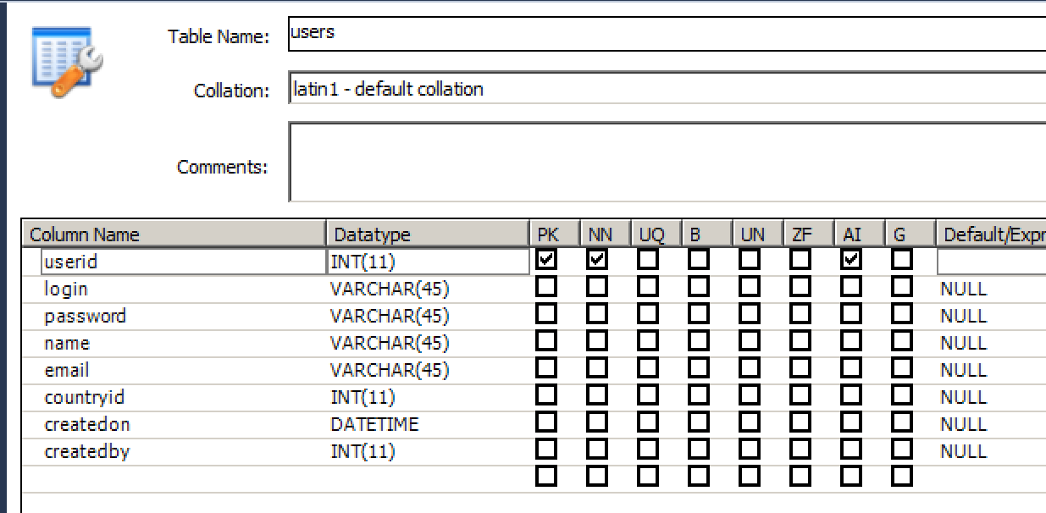

**Roles Table**

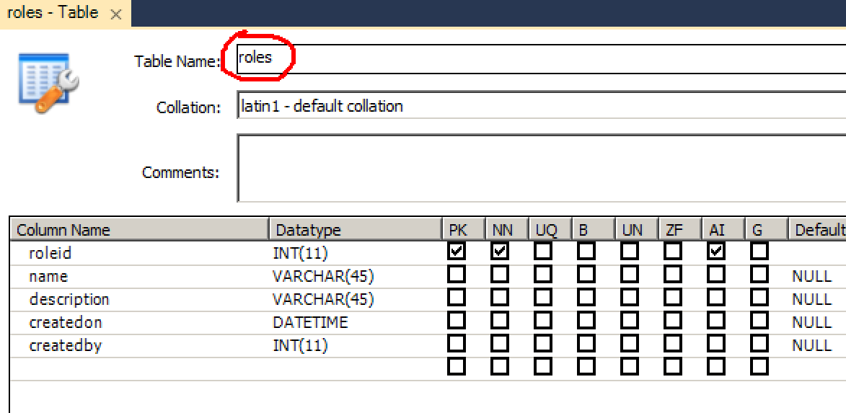

**Permissions Table**

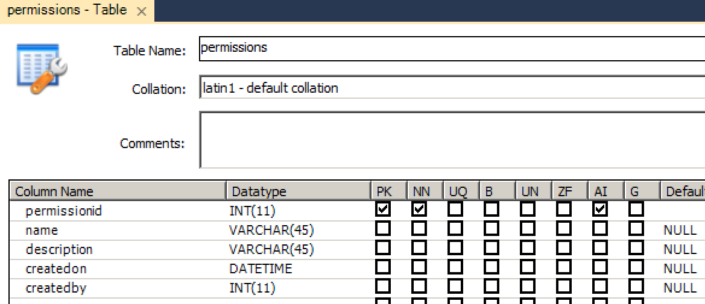

**Role Permission Table**

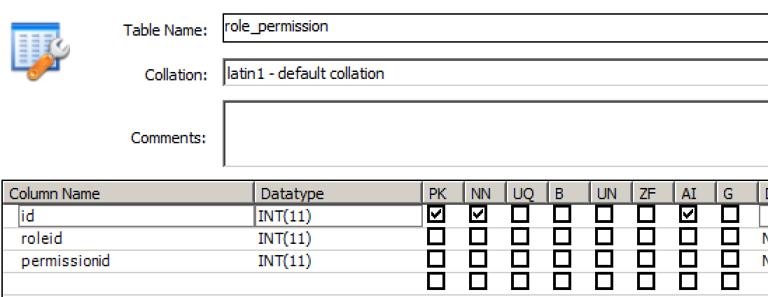

**User Role**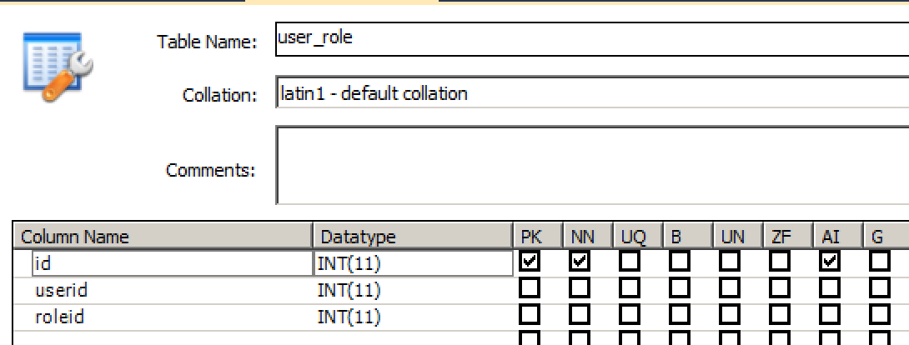

**Login History**

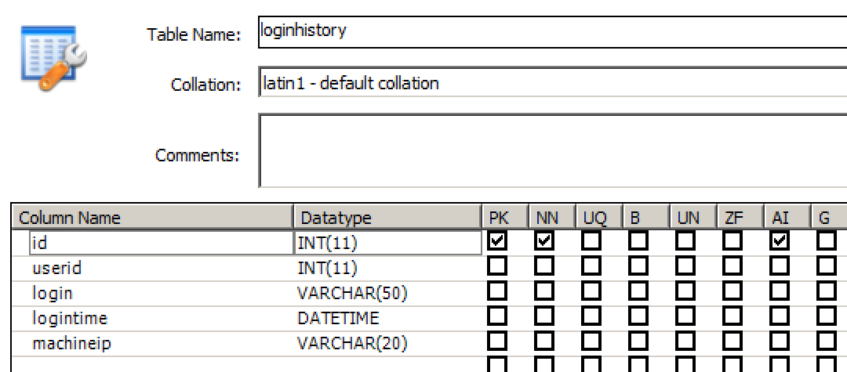

**Country (You may add some country directly in this table)**

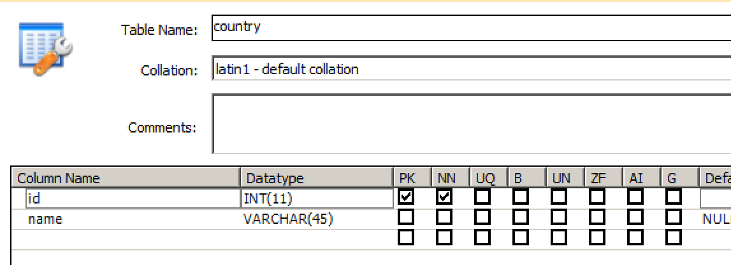

**City**

**TableName: city**

|  |  |  |
| --- | --- | --- |
| **Column Name** | **type** | **Other** |
| **id** | **int** | **PK, NN** |
| **Name** | **varchar(50)** |  |
| **countryid** | **int** |  |

**FAQs from Assignment 3:**

**Q#1 can we use AJAX in the Assignment?**

**Answer:** Yes